CLASS NOTES – Summer 2025

Logan Miles, Class of 2019 works for the Bandera County EMS, which was deployed to the Kerr County July 4th flooding tragedy as part of the Southwest Regional Advisory Council (STRAC). Originally, Logan and his work partner, Amber, were assigned to a task force responsible for search and rescue, to be available if a person was rescued or one of the response members needed aid. Later, his truck was reassigned to aid the local 911 first response doing what he normally does in Bandera County. Thank you, Logan, for representing Schreiner well! You are our hero!
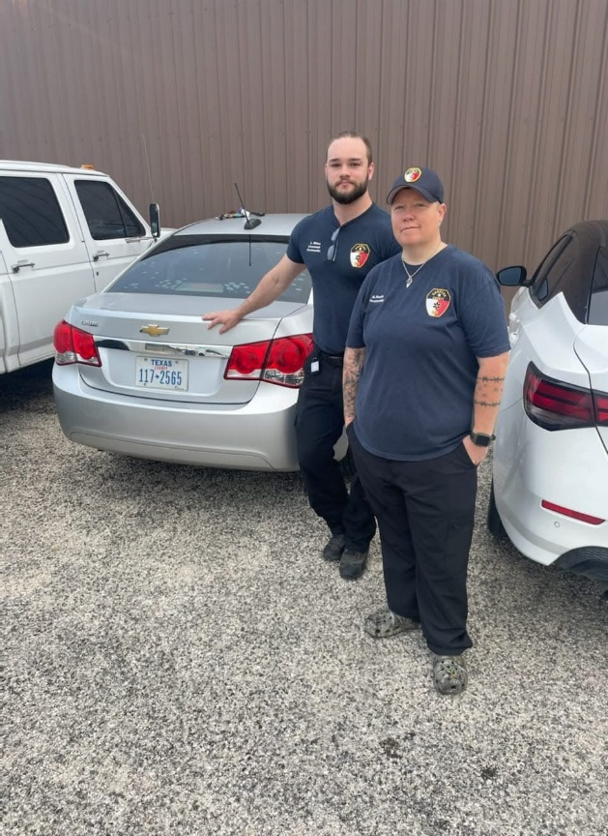
Logan Miles with partner Amber before they went to help with relief efforts after Hurricane Beryl.

Alicia Jaks, RN to BSN, Class of 2019 emailed to get a replacement Alumni Card and let us know she has been working at the Veterans Affairs Hospital in Kerrville since January.
Alicia also let us know of four other Schreiner Alums currently working at the VA:
- Brady Crider, Class of 2004 – Nurse Manager
- Sarah Otka, Class of 2008 – Nurse Manager
- Kimberly MacNaughton, Class of 1978 – Nurse Educator
- Theresa Wilkerson, Class of 1997 – Resource Utilization Groups “RUG” Nurse
Thank you, nurses! We are so grateful for your service to those who served! You truly are living a Purposeful Life, and we are so proud of you.

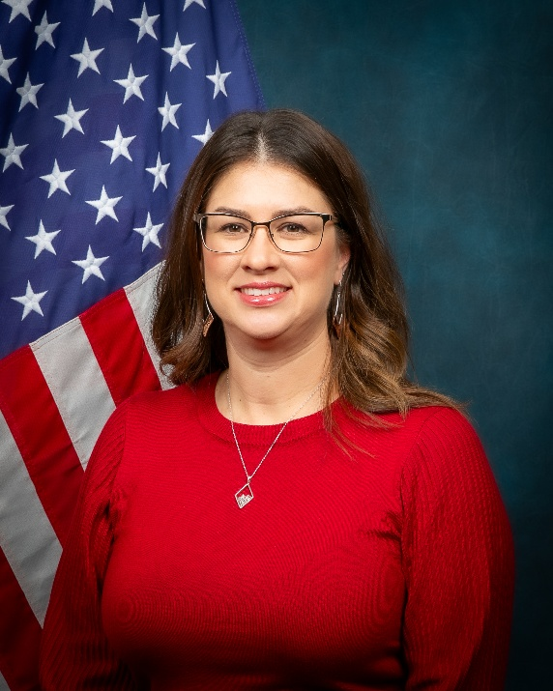
Alicia Jaks, RN, BSN

Alyssa (Nease) Basquez, Class of 2020 shared some good news since graduating. She met the love of her life in 2021, got saved in 2022, got engaged and married in 2024 to Christian Basquez, and had a beautiful baby boy named Roman in April 2025. Alyssa also works as a Director at the Kerrville Chick-fil-a. Good news like this is always welcomed, Alyssa! Congratulations on your beautiful family!
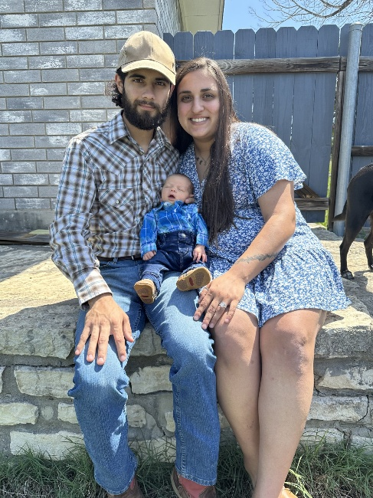
Christian & Alyssa Basquez with baby Roman

Lauren (Wise) Treviño, Class of 2016 - started her MA in English at UTSA, got married in February, and has transitioned from her copywriting career of eight years to teaching at Ambleside School of Boerne alongside her new husband. She will be teaching Kindergarten. Thanks, Lauren, for the update, and we wish you great joy and success in your new marriage and career!
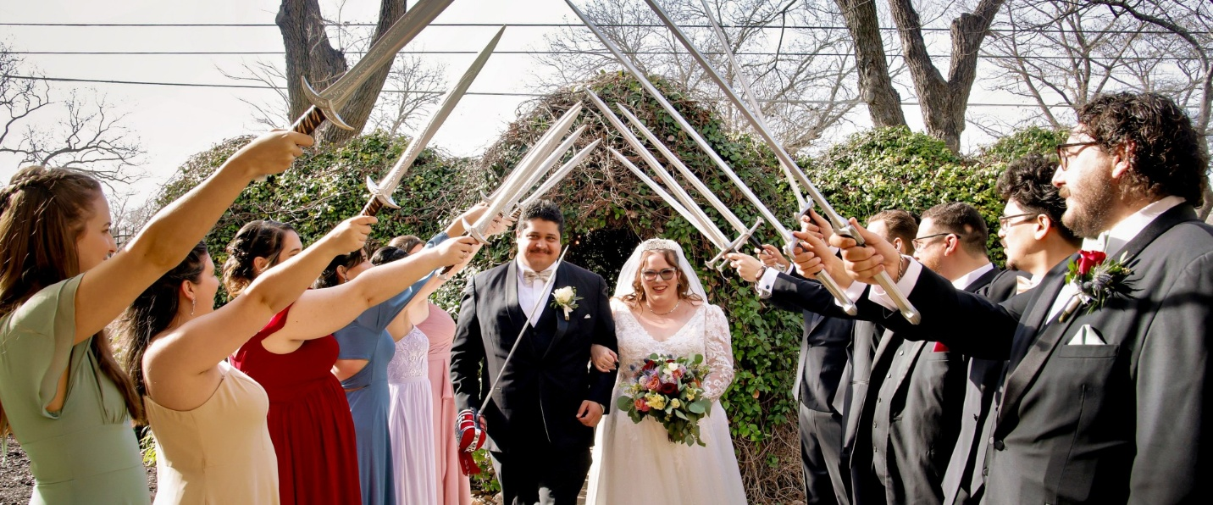
Alejandro and Lauren Treviño on their wedding day!
Meagan (Kunkel) Glidden, Class of 2008 and her husband, Travis, welcomed baby boy Ace into the world this summer. Their dog, Whip, approved! Congratulations on all that cuteness!

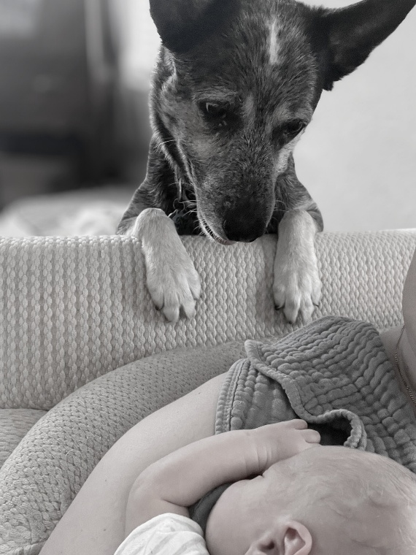
Whip checking out his new housemate.

Baby Ace!

